Bv

Av

Figure 1. Axial (A) and coronal (B) and projection of the patient’s CBCT with bilateral impacted maxillary canines

Bv

Av

Figure 2. Extraction of right (A) and left (B) maxillary deciduous canine

Bv

Av

Figure 3. Vestibular surgical approach of right impacted maxillary canine (A) and palatal surgical approach of left impacted maxillary canine (B)

Av

Bv

Figure 4. Traction pin placement and chain placement on right (A) and left (B) impacted maxillary canine

Av

Bv

Figure 5. Eruption of right maxillary canine 9 months after initation of the tretament (A). Eruption of lefth maxillary canine 12 months after initation of the tretament (B)

Av

Bv

Figure 6. Maxillary right and left canines 24 months after initation of the tretament

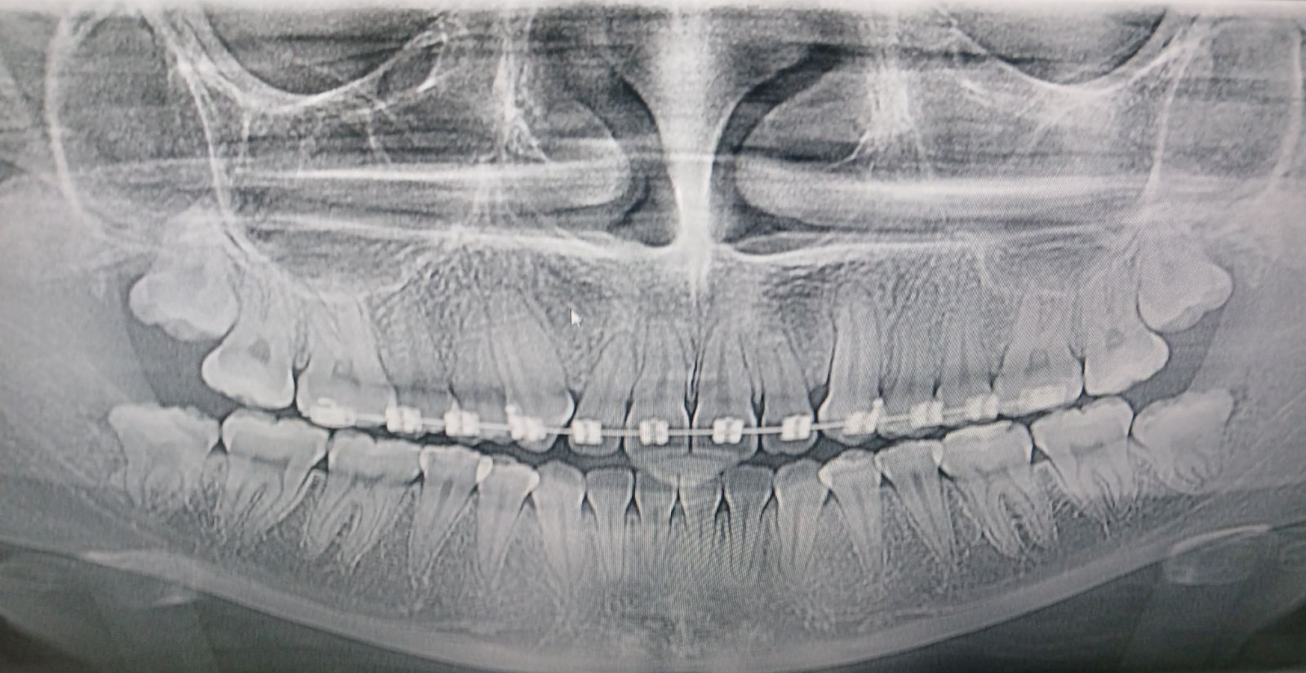

Figure 7.Control panoramic radiograph two years after the beginning of therapy